
CHANAKYA UNIVERSITY
SCHOOL OF ENGINEERING

ASSIGNMENT TITLE: CHANAKYA UNIVERSITY DIGITAL PATH FINDER
ASSIGNMENT -1

SEMESTER III (ODD)
SUBJECT: INTRODUCTION TO AIML
SECTION B

SUBMITTED BY:
GANESH NAYAK GS
REGISTER NO: 24UG00518

ABSTRACT
The Bot Brain project is about building a smart digital assistant to help people find their way around Chanakya University. It looks at the campus like a map made of points and lines—where buildings are the points (nodes) and the paths between them are the lines (edges). Bot Brain uses well-known search methods like BFS, DFS, UCS, and A* to quickly find the best route from one place to another. It also gives useful details about each building, such as what services are available, when they’re open, and what they’re used for—making life easier for students and visitors. One of the main goals is to let students see how different search methods work and compare how fast and efficient they are in real situations. By combining route finding, helpful building info, and algorithm learning, Bot Brain offers a smart and practical tool that makes the campus more accessible, efficient.
INTRODUCTION
A university campus is like a small town, with classrooms, hostels, and places to relax. For new students, finding their way around can be tricky. There are long paths, many buildings, and not many helpful tools to guide them. Old methods like signboards or printed maps don’t always help enough.
The Bot Brain project uses AI to make things easier. It treats the campus like a map made of dots and lines—dots for buildings and lines for paths. It uses smart search methods like A*, UCS, BFS, and DFS to find the best way to get from one place to another. It also gives useful details about each building, like what’s inside, when it’s open, and what it’s used for. This project doesn’t just help people move around—it also teaches students how AI works, how different search methods perform.
PROBLEM STATEMENT
New students and visitors often find it hard to move around Chanakya University’s large and unfamiliar campus. They face problems like not knowing where buildings are, spending too much time searching for classrooms or offices, asking others for directions, and not having quick access to building details like services or opening hours. All of this leads to confusion, delays, and unnecessary stress.
To solve this, there’s a need for a smart campus guide that helps users find the shortest paths, shows how long it takes to walk somewhere, and gives useful building information. This would make it much easier for newcomers to explore the campus smoothly and confidently.

Objectives
- Use search methods like BFS, DFS, UCS, and A* to find the best routes.
- Compare how fast and accurate each method is.
- Build a chatbot that understands everyday questions.
- Add building info like services, timings, and staff details to the system.

Scope
Covers navigation within the Chanakya University campus only.
- Includes 12+ key buildings: academic blocks, library, admin block, hostel, canteen, sports complex, medical centre, etc.
- Provides shortest routes, total distance, and estimated walking times.
- Implements four search algorithms (BFS, DFS, UCS, A*).
- Delivers facility details via chatbot.
- Future scope includes integration with academic portals for personalized assistance.
REQUIREMENTS
Functional Requirements
- Show the campus as a map with buildings and paths using a graph model.
- Use search methods like BFS, DFS, UCS, and A* to find routes.
- Answer questions like “How do I get from Hostel to Library?”
- Show the route, how far it is, and how long it takes to walk.
- Include FAQs and basic info about building services.
Non-Functional Requirements
- Accuracy: Give correct and shortest routes.
- Speed: Respond quickly using smart search methods.
- Flexibility: Easy to add more buildings and services later.
- Ease of Use: Simple text-based system to start with.

LITERATURE REVIEW
- Pathfinding Algorithms: Different search methods help find routes in various ways. BFS looks for the shortest path by steps, DFS goes deep but can miss better options, UCS finds the cheapest route, and A* uses smart guesses to speed things up.
- Campus Navigation Tools: Some past systems used mobile apps or QR codes to guide users around campuses. However, most didn’t include chatbots that could talk to users and answer questions.
- Chatbots in Education: Chatbots have been used to help students with common questions, admissions, and general support. Using them to guide people around a campus is a new and creative idea.
- Smart Agents: Research shows that to build intelligent systems, it’s important to design agents that understand their surroundings, have tools to sense and act, and clear goals to follow. This helps them make better decisions.
TOOLS AND TECHNOLOGIES USED
- We used Python to build the main system.
- The search methods—BFS, DFS, UCS, and A*—were coded from scratch using basic Python tools.
- To estimate real distances between places, we used the Google Maps API.
- For handling graphs and visuals, we used tools like NetworkX for graph setup, Matplotlib for drawing, and NumPy for math work.
- The project was managed and shared using GitHub, and designs like chatbot screens.
- All coding was done in VS Code,

CAMPUS LAYOUT
- Main Gate
- Security gate
- Administration block
- Library
- cafeteria
- Block 2
- Food Court
- Hostel block
- Mini mart
- Sports area
- Auditorium

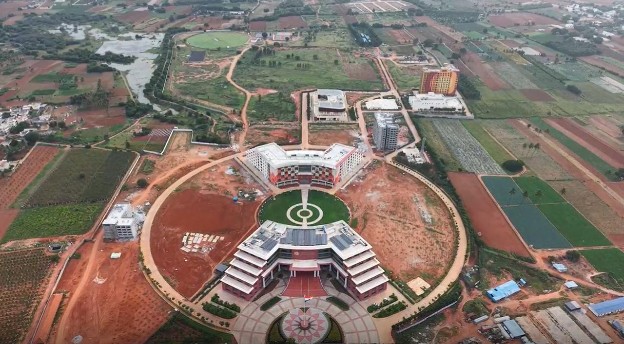

Block diagram

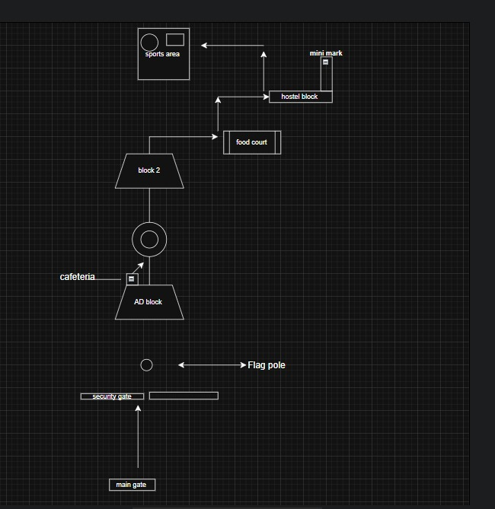

System Architecture Diagram
User
↓
Chatbot interface
↓
Bot Engine

Pathfinding Database
Module

Campus Graph

Output (Route

1.System Architecture Overview
The system works step-by-step:
User → Chatbot → Language Understanding → Route Finder → Info Database
A user types a question.
- The chatbot receives it and passes it to the language engine.
- The engine figures out what the user wants—like directions or building info.
- The route finder uses search methods (BFS, DFS, UCS, A*) to find the best path.
- The database gives answers like FAQs, staff contacts, or building details.
2. Main Parts of the System
- Chatbot Interface: Users ask questions through a simple text box.
- Language & Bot Engine: Understands the type of question—whether it’s about directions, staff, or general info.
- Pathfinding Module: Uses smart search methods to find routes across campus.
Database: Holds building info, staff contacts, and FAQs. You can start with Python dictionaries for this.
3. Database Structure
- Even if not fully built, planning the database shows good design. Here’s a basic layout:
- Locations: ID, name, description, timings
- Paths: ID, starting point, ending point, distance
- Staff: ID, name, department, office location, contact info
- FAQs: ID, question, answer
4. How It Was Built (Methodology)
- The campus was turned into a graph—buildings as points, paths as lines.
- Search methods (BFS, DFS, UCS, A*) were coded to find routes.
- The system was split into clear parts: chatbot, language engine, route finder, and database.
- A database layout was created to store all needed info.
- Sample questions like “How do I get from Library to Hostel?” were used to test the system.
5. Example Query
Question: Find path from Library to Hostel
Answer: Library → Student Center → Hostel
Distances:
Library to food court
Food court to Hostel
This shows that the search methods are working well for campus navigation.

- Methodology
To build the system, the campus was treated like a map made of points and lines—where each place is a point (node) and each path is a line (edge). Four search methods—BFS, DFS, UCS, and A*—were used to find routes between locations. The system was split into clear parts: user interface, language understanding, route finder, and database. A basic database structure was created to store building and staff info. The system was tested using example questions like “How do I get from Library to Hostel?”
- Sample Pathfinding Query
- Query: Find path from Library to Hostel
Result: Library → Student Center → Hostel
Distances:
- Library to Student Center
- Student Center to Hostel

Campus Path Navigator
Campus Path Navigator Overview
1. Chatbot & Interface
A simple desktop app was built using Tkinter (Python).
Users can pick starting and ending points from dropdown menus.
There’s also an option to choose a department to find staff contacts.
Results are shown clearly in a text box.
1. Pathfinding Algorithm Integration-
BFS (Breadth First Search): Finds shortest path in terms of hops. –
DFS (Depth First Search): Explores deeper paths first.
- UCS (Uniform Cost Search): Guarantees shortest path by distance.
- A* Search Algorithm: Framework added for heuristic-based navigation (currently heuristic = 0, can be improved later). Each algorithm returns both the path (sequence of locations) and the distance (in meters).
3. Campus Distance Data
- Created a distance dictionary storing distances (in meters) between major campus locations such as: Admin Block, Academic Block, Library, Cafeteria, Auditorium, Hostel, Medical, Mini Mart, Sports Complex, etc.- Used this dataset as input for the pathfinding algorithms.
4.Prototype Demonstration
- User can:- Select a start and end location → Get navigation path & distance using chosen algorithm.- Select a department → Retrieve staff details instantly. - Output is displayed in a text area for easy readability

CODE

from flask import Flask, render_template, request, jsonify
from queue import PriorityQueue
import math

app = Flask(__name__)

# Coordinates of locations
locations = {
'main_gate': (13.2200, 77.7539),
'id_gate': (13.2214, 77.7549),
'flag_pole': (13.2218, 77.7550),
'admin_block': (13.2222, 77.7552),
'library': (13.221971, 77.75558),
'vending': (13.222264, 77.755126),
'cafeteria': (13.22242, 77.755158),
'lawn_area': (13.222775, 77.755576),
'block_2': (13.22336, 77.755963),
'food_court': (13.224758, 77.75725),
'hostel': (13.224195, 77.758613),
'sports_area': (13.22887, 77.7572)
}

# Graph representation with distances (in meters)
graph = {
'main_gate': {'id_gate': 156},
'id_gate': {'main_gate': 156, 'flag_pole': 45},
'flag_pole': {'id_gate': 45, 'admin_block': 45, 'library': 30},
'admin_block': {'flag_pole': 45, 'vending': 20, 'cafeteria': 25},
'library': {'flag_pole': 30, 'vending': 35},
'vending': {'admin_block': 20, 'library': 35, 'cafeteria': 15},
'cafeteria': {'admin_block': 25, 'vending': 15, 'lawn_area': 50},
'lawn_area': {'cafeteria': 50, 'block_2': 65},
'block_2': {'lawn_area': 65, 'food_court': 85, 'hostel': 70},
'food_court': {'block_2': 85, 'sports_area': 200},
'hostel': {'block_2': 70, 'sports_area': 150},
'sports_area': {'food_court': 200, 'hostel': 150}
}

def haversine_distance(coord1, coord2):
"""Calculate distance between two coordinates using Haversine formula"""
lat1, lon1 = coord1
lat2, lon2 = coord2

R = 6371000 # Earth radius in meters
phi1 = math.radians(lat1)
phi2 = math.radians(lat2)
delta_phi = math.radians(lat2 - lat1)
delta_lambda = math.radians(lon2 - lon1)

a = math.sin(delta_phi/2)**2 + math.cos(phi1)*math.cos(phi2)*math.sin(delta_lambda/2)**2
c = 2 * math.atan2(math.sqrt(a), math.sqrt(1-a))

return R * c

def bfs(start, goal):
"""Breadth-First Search"""
if start == goal:
return [start], 0

queue = [[start]]
visited = set([start])

while queue:
path = queue.pop(0)
node = path[-1]

if node == goal:
distance = calculate_path_distance(path)
return path, distance

for neighbor in graph.get(node, {}):
if neighbor not in visited:
visited.add(neighbor)
new_path = list(path)
new_path.append(neighbor)
queue.append(new_path)

return None, 0

def dfs(start, goal):
"""Depth-First Search"""
if start == goal:
return [start], 0

stack = [[start]]
visited = set([start])

while stack:
path = stack.pop()
node = path[-1]

if node == goal:
distance = calculate_path_distance(path)
return path, distance

for neighbor in graph.get(node, {}):
if neighbor not in visited:
visited.add(neighbor)
new_path = list(path)
new_path.append(neighbor)
stack.append(new_path)

return None, 0

def ucs(start, goal):
"""Uniform Cost Search"""
if start == goal:
return [start], 0

pq = PriorityQueue()
pq.put((0, [start]))
visited = set()

while not pq.empty():
cost, path = pq.get()
node = path[-1]

if node == goal:
return path, cost

if node not in visited:
visited.add(node)

for neighbor, edge_cost in graph.get(node, {}).items():
if neighbor not in visited:
total_cost = cost + edge_cost
new_path = list(path)
new_path.append(neighbor)
pq.put((total_cost, new_path))

return None, 0

def calculate_path_distance(path):
"""Calculate total distance of a path"""
total_distance = 0
for i in range(len(path) - 1):
total_distance += graph[path[i]][path[i+1]]
return total_distance

@app.route('/')
def index():
return render_template('index.html', locations=locations.keys())

@app.route('/find-path', methods=['POST'])
def find_path():
data = request.json
start = data['start']
goal = data['goal']
algorithm = data['algorithm']

if start not in locations or goal not in locations:
return jsonify({'error': 'Invalid locations'}), 400

if start == goal:
return jsonify({'error': 'Start and goal cannot be the same'}), 400

# Find path based on algorithm
if algorithm == 'bfs':
path, distance = bfs(start, goal)
elif algorithm == 'dfs':
path, distance = dfs(start, goal)
elif algorithm == 'ucs':
path, distance = ucs(start, goal)
else:
return jsonify({'error': 'Invalid algorithm'}), 400

if not path:
return jsonify({'error': 'No path found'}), 400

# Convert path to coordinates
path_coordinates = [{'lat': locations[node][0], 'lng': locations[node][1], 'name': node.replace('_', ' ').title()} for node in path]

return jsonify({
'path': path_coordinates,
'distance': distance,
'algorithm': algorithm.upper()
})

if __name__ == '__main__':
app.run(debug=True)

And html code

<!DOCTYPE html>
<html lang="en">
<head>
<meta charset="UTF-8">
<meta name="viewport" content="width=device-width, initial-scale=1.0">
<title>Campus Navigation</title>
<link rel="stylesheet" href="https://unpkg.com/leaflet@1.7.1/dist/leaflet.css" />
<style>
body {
margin: 0;
padding: 0;
font-family: Arial, sans-serif;
}

.container {
display: flex;
height: 100vh;
}

.sidebar {
width: 300px;
background: #f8f9fa;
padding: 20px;
border-right: 1px solid #ddd;
overflow-y: auto;
}

.map-container {
flex: 1;
height: 100%;
}

#map {
height: 100%;
width: 100%;
}

.form-group {
margin-bottom: 15px;
}

label {
display: block;
margin-bottom: 5px;
font-weight: bold;
}

select, button {
width: 100%;
padding: 8px;
border: 1px solid #ddd;
border-radius: 4px;
}

button {
background: #007bff;
color: white;
border: none;
cursor: pointer;
font-size: 16px;
}

button:hover {
background: #0056b3;
}

.result {
margin-top: 20px;
padding: 15px;
background: white;
border-radius: 4px;
border-left: 4px solid #007bff;
}

.path-info {
background: #e7f3ff;
padding: 10px;
border-radius: 4px;
margin-top: 10px;
}

.error {
background: #ffe6e6;
border-left: 4px solid #dc3545;
}
</style>
</head>
<body>
<div class="container">
<div class="sidebar">
<h2>Campus Navigation</h2>

<div class="form-group">
<label for="start">Start Location:</label>
<select id="start">
<option value="">Select start location</option>
<option value="main_gate">Main Gate</option>
<option value="id_gate">ID Gate</option>
<option value="flag_pole">Flag Pole</option>
<option value="admin_block">Admin Block</option>
<option value="library">Library</option>
<option value="vending">Vending</option>
<option value="cafeteria">Cafeteria</option>
<option value="lawn_area">Lawn Area</option>
<option value="block_2">Block 2</option>
<option value="food_court">Food Court</option>
<option value="hostel">Hostel</option>
<option value="sports_area">Sports Area</option>
</select>
</div>

<div class="form-group">
<label for="goal">Destination:</label>
<select id="goal">
<option value="">Select destination</option>
<option value="main_gate">Main Gate</option>
<option value="id_gate">ID Gate</option>
<option value="flag_pole">Flag Pole</option>
<option value="admin_block">Admin Block</option>
<option value="library">Library</option>
<option value="vending">Vending</option>
<option value="cafeteria">Cafeteria</option>
<option value="lawn_area">Lawn Area</option>
<option value="block_2">Block 2</option>
<option value="food_court">Food Court</option>
<option value="hostel">Hostel</option>
<option value="sports_area">Sports Area</option>
</select>
</div>

<div class="form-group">
<label for="algorithm">Pathfinding Algorithm:</label>
<select id="algorithm">
<option value="bfs">Breadth-First Search (BFS)</option>
<option value="dfs">Depth-First Search (DFS)</option>
<option value="ucs">Uniform Cost Search (UCS)</option>
</select>
</div>

<button id="find-path">Find Path</button>

<div id="result"></div>
</div>

<div class="map-container">
<div id="map"></div>
</div>
</div>

<script src="https://unpkg.com/leaflet@1.7.1/dist/leaflet.js"></script>
<script>
// Initialize map
const map = L.map('map').setView([13.2222, 77.7552], 16);

// Add MapTiler layer
L.tileLayer('https://api.maptiler.com/maps/streets/{z}/{x}/{y}.png?key=9eknIXAwnjUnd8gwntx4', {
attribution: '<a href="https://www.maptiler.com/copyright/" target="_blank">&copy; MapTiler</a>'
}).addTo(map);

// Location coordinates
const locations = {
'main_gate': [13.2200, 77.7539],
'id_gate': [13.2214, 77.7549],
'flag_pole': [13.2218, 77.7550],
'admin_block': [13.2222, 77.7552],
'library': [13.221971, 77.75558],
'vending': [13.222264, 77.755126],
'cafeteria': [13.22242, 77.755158],
'lawn_area': [13.222775, 77.755576],
'block_2': [13.22336, 77.755963],
'food_court': [13.224758, 77.75725],
'hostel': [13.224195, 77.758613],
'sports_area': [13.22887, 77.7572]
};

// Add markers for all locations
const markers = {};
Object.keys(locations).forEach(location => {
const coords = locations[location];
markers[location] = L.marker(coords)
.addTo(map)
.bindPopup(location.replace('_', ' ').toUpperCase());
});

let pathLayer = null;
let startMarker = null;
let goalMarker = null;

document.getElementById('find-path').addEventListener('click', findPath);

async function findPath() {
const start = document.getElementById('start').value;
const goal = document.getElementById('goal').value;
const algorithm = document.getElementById('algorithm').value;
const resultDiv = document.getElementById('result');

if (!start || !goal) {
showResult('Please select both start and destination locations.', 'error');
return;
}

if (start === goal) {
showResult('Start and destination cannot be the same.', 'error');
return;
}

try {
const response = await fetch('/find-path', {
method: 'POST',
headers: {
'Content-Type': 'application/json',
},
body: JSON.stringify({
start: start,
goal: goal,
algorithm: algorithm
})
});

const data = await response.json();

if (!response.ok) {
showResult(data.error, 'error');
return;
}

// Clear previous path
if (pathLayer) {
map.removeLayer(pathLayer);
}

// Clear previous markers
if (startMarker) map.removeLayer(startMarker);
if (goalMarker) map.removeLayer(goalMarker);

// Add special markers for start and goal
startMarker = L.marker(locations[start], {
icon: L.divIcon({
className: 'start-marker',
html: '🟢',
iconSize: [20, 20]
})
}).addTo(map).bindPopup('START: ' + start.replace('_', ' ').toUpperCase());

goalMarker = L.marker(locations[goal], {
icon: L.divIcon({
className: 'goal-marker',
html: '🔴',
iconSize: [20, 20]
})
}).addTo(map).bindPopup('GOAL: ' + goal.replace('_', ' ').toUpperCase());

// Draw path
const pathCoords = data.path.map(point => [point.lat, point.lng]);
pathLayer = L.polyline(pathCoords, {
color: 'blue',
weight: 5,
opacity: 0.7,
smoothFactor: 1
}).addTo(map);

// Fit map to show the entire path
map.fitBounds(pathLayer.getBounds());

// Show result
const pathSteps = data.path.map((point, index) =>
`${index + 1}. ${point.name}`
).join('<br>');

showResult(`
<div class="path-info">
<strong>Algorithm:</strong> ${data.algorithm}<br>
<strong>Distance:</strong> ${data.distance} meters<br>
<strong>Path:</strong><br>${pathSteps}
</div>
`);

} catch (error) {
showResult('Error finding path: ' + error.message, 'error');
}
}

function showResult(message, type = 'success') {
const resultDiv = document.getElementById('result');
resultDiv.innerHTML = `<div class="result ${type === 'error' ? 'error' : ''}">${message}</div>`;
}

// Add some custom CSS for markers
const style = document.createElement('style');
style.textContent = `
.start-marker, .goal-marker {
font-size: 18px;
text-align: center;
}
`;
document.head.appendChild(style);
</script>
</body>
</html>

output

